# Question Set 04

### Critical Radius of insulation

|  |  |  |  |
| --- | --- | --- | --- |
| Critical Radius Exploration | | | |
|  | | | |
| ***r₂*** | ***R ins*** | ***R conv*** | ***Rins + R conv*** |
| m | K / W | K / W | K / W |
| 0.003 | 0 | 10.61 | 10.61 |
| 0.006 | 3.06 | 5.31 | 8.37 |
| 0.009 | 4.86 | 3.54 | 8.39 |
| 0.012 | 6.13 | 2.65 | 8.78 |
| 0.015 | 7.12 | 2.12 | 9.24 |
| 0.018 | 7.92 | 1.77 | 9.69 |
| 0.021 | 8.60 | 1.52 | 10.12 |
| 0.024 | 9.19 | 1.33 | 10.52 |
| 0.027 | 9.71 | 1.18 | 10.89 |

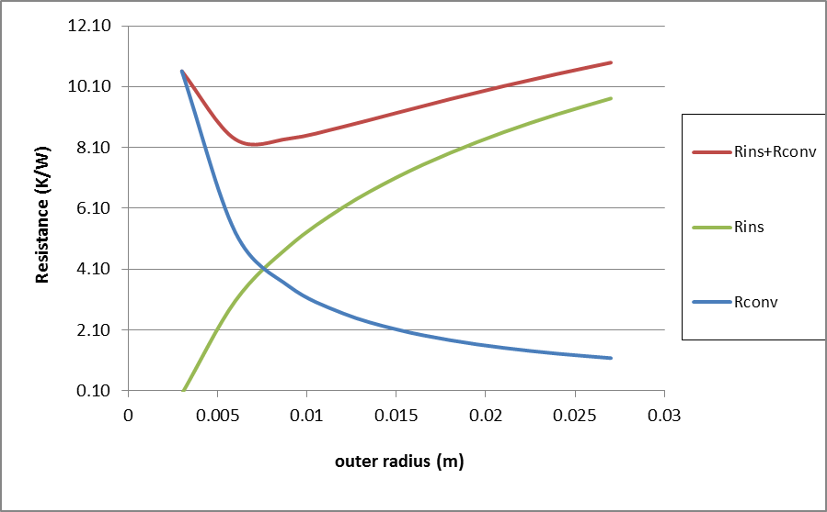

It is apparent from the table or the graph that adding insulation for the first few millimetres of thickness decreases the convective resistance more than it increases the insulation resistance with the result that the combined resistance drops!!! So adding insulation would have caused an increase in heat loss!! When the outer radius exceeds the critical radius it can be seen that further addition of insulation does cause the combined resistance to increase beyond the minimum value experienced when the outer radius equalled the critical radius.

1. rcrit= k/h = 0.036/5 = 0.0072m, i.e. 7.2mm

(ii) ; ; 

1. For a cylindrical pipe, the critical radius of insulation is defined as . On windy days, the external convection heat transfer coefficient is greater compared to calm days. Therefore critical radius of insulation will be greater on calm days.
2. The fin efficiency is defined as the ratio of actual heat transfer rate from the fin to the ideal heat transfer rate from the fin if the entire fin were at base temperature, and its value is between 0 and 1. Fin effectiveness is defined as the ratio of heat transfer rate from a finned surface to the heat transfer rate from the same surface if there were no fins, and its value is expected to be greater than 1.
3. The fin with the lower heat transfer coefficient will have the higher efficiency and the higher effectiveness.
4. Fins should be attached on the air side since the convection heat transfer coefficient is lower on the air side than it is on the water side.
5. Increasing the length of a fin decreases its efficiency but increases its effectiveness.
6. ***Analysis*** In case of no fins, heat transfer from the tube per meter of its length is

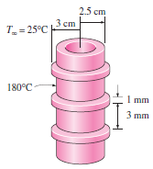 

The efficiency of these circular fins is, from the efficiency curve,



Heat transfer from a single fin is



Heat transfer from a single unfinned portion of the tube is



There are 250 fins and thus 250 interfin spacings per meter length of the tube. The total heat transfer from the finned tube is then determined from



Therefore the increase in heat transfer from the tube per meter of its length as a result of the addition of the fins is



1. *Assumptions* Steady operating conditions exist. The temperature in the board and along the fins varies in one direction only (normal to the board). All the heat generated in the chips is conducted across the circuit board, and is dissipated from the back side of the board. Heat transfer from the fin tips is negligible. The heat transfer coefficient is constant and uniform over the entire fin surface. The thermal properties of the fins are constant. The heat transfer coefficient accounts for the effect of radiation from the fins.

***Properties*** The thermal conductivities are given to be *k* = 20 W/m⋅°C for the circuit board, *k* = 237 W/m⋅°C for the aluminum plate and fins, and *k* = 1.8 W/m⋅°C for the epoxy adhesive.

***Analysis*** (*a*) The total rate of heat transfer dissipated by the chips is



The individual resistances are

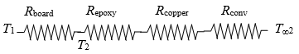







The temperatures on the two sides of the circuit board are



Therefore, the board is nearly isothermal.

(*b*) Noting that the cross-sectional areas of the fins are constant, the efficiency of the circular fins can be determined to be





The fins can be assumed to be at base temperature provided that the fin area is modified by multiplying it by 0.973. Then the various thermal resistances are



  



Then the temperatures on the two sides of the circuit board becomes



1. –

### Numerical Conduction

1. (*a*) heat transfer in this medium is **steady**, (*b*) it is **one-dimensional**, (*c*) there **is** heat generation, (*d*) the nodal spacing is **constant**, and (*e*) the thermal conductivity is **constant**.
2. ***Analysis***Using the energy balance approach and taking the direction of all heat transfers to be towards the node under consideration, the finite difference formulations become

Node 0 (at left boundary): 

Node 1 (at the mid plane): 

Node 2 (at right boundary): 

1. ***Analysis***The nodal network consists of 3 nodes, and the base temperature *T*0 at node 0 is specified. Therefore, there are two unknowns *T*1and *T*2, and we need two equations to determine them. Using the energy balance approach and taking the direction of all heat transfers to be towards the node under consideration, the finite difference formulations become

Node 1 (at midpoint): 

Node 2 (at fin tip): 

where  is the cross-sectional area and  is the perimeter of the fin.

1. ***Properties***The thermal conductivity is given to be *k* = 237 W/m⋅°C.

***Analysis*** (*a*) The nodal spacing is given to be Δ*x*=0.5 cm. Then the number of nodes *M* becomes



The base temperature at node 0 is given to be *T*0 = 130°C. This problem involves 4 unknown nodal temperatures, and thus we need to have 4 equations to determine them uniquely. Nodes 1, 2, and 3 are interior nodes, and thus for them we can use the general finite difference relation expressed as

 → 

The finite difference equation for node 4 at the fin tip is obtained by applying an energy balance on the half volume element about that node. Then,

*m*= 1: 

*m*= 2: 

*m*= 3: 

Node 4: 

where 

and .

This system of 4 equations with 4 unknowns constitute the finite difference formulation of the problem.

(*b*) The nodal temperatures under steady conditions are determined by solving the 4 equations above simultaneously with an equation solver to be

***T*1 =129.2°C,  *T*2 =128.7°C, *T*3 =128.3°C, *T*4 =128.2°C**

(*c*) The rate of heat transfer from a single fin is simply the sum of the heat transfer from each nodal element,



(*d*) The number of fins on the surface is



Then the rate of heat tranfer from the fins, the unfinned portion, and the entire finned surface become



1. Heat transfer is steady, (*b*) heat transfer is two-dimensional, (*c*) there is no heat generation in the medium, (*d*) the nodal spacing is constant, and (*e*) the thermal conductivity of the medium is constant.
2. ***Analysis***The nodal spacing is given to be Δ*x*=Δ*x*=*l*=0.01 m, and the general finite difference form of an interior node for steady two-dimensional heat conduction for the case of no heat generation is expressed as



There is symmetry about the horizontal, vertical, and diagonal lines passing through the midpoint, and thus we need to consider only 1/8th of the region. Then,



Therefore, there are there are only 3 unknown nodal temperatures, , and thus we need only 3 equations to determine them uniquely. Also, we can replace the symmetry lines by insulation and utilize the mirror-image concept when writing the finite difference equations for the interior nodes.



Solving the equations above simultaneously gives



***Discussion*** Note that taking advantage of symmetry simplified the problem greatly.

1. The formulation of a transient heat conduction problem differs from that of a steady heat conduction problem in that the transient problem involves an *additional term* that represents the *change in the energy content* of the medium with time. This additional term  represent the change in the internal energy content during Δ*t* in the transient finite difference formulation.
2. The two basic methods of solution of transient problems based on finite differencing are the *explicit* and the *implicit methods*. The heat transfer terms are expressed at time step *i* in the explicit method, and at the future time step *i* + 1 in the implicit method as

Explicit method: 

Implicit method: 

1. For transient one-dimensional heat conduction in a plane wall with both sides of the wall at specified temperatures, the stability criteria for the explicit method can be expressed in its simplest form as



1. ***Analysis***The nodal network consists of 3 nodes, and the base temperature *T*0 at node 0 is specified. Therefore, there are two unknowns *T*1and *T*2, and we need two equations to determine them. Using the energy balance approach and taking the direction of all heat transfers to be towards the node under consideration, the explicit transient finite difference formulations become

Node 1 (at midpoint):



Node 2 (at fin tip):



where is the cross-sectional area and is the perimeter of the fin.



1. ***Analysis***The nodal network of this problem consists of 5 nodes, and the base temperature *T*0 at node 0 is specified. Therefore, there are 4 unknown nodal temperatures, and we need 4 equations to determine them. Using the energy balance approach and taking the direction of all heat transfers to be towards the node under consideration, the explicit transient finite difference formulations become

Node 1 (interior): 

Node 2 (interior): 

Node 3 (interior): 

Node 4 (fin tip): 

where  is the cross-sectional area and  is the perimeter of the fin. Also, *D* = 0.008 m, *k* = 237 W/m.C, , Δ*x* = 0.02 m, *T*∞= 30°C, *T*0= 120°C *h*o= 35 W/m2.°C, and Δ*t* = 1 s. Also, the mesh Fourier number is



Substituting these values, the nodal temperatures along the fin after 5×60 = 300 time steps (4 h) are determined to be

***T*0 = 120°C, *T*1 = 110.6°C, *T*2 = 103.9°C, *T*3 = 100.0°C, and *T*4 = 98.5°C.**

Printing the temperatures after each time step and examining them, we observe that the nodal temperatures stop changing after about 3.8 min. Thus we conclude that steady conditions are reached after **3.8 min.**